**To re-class wrong balance of loan of related party to staff loan included outstanding balance, AIR and Interest income:**

132510-Standard Loans – Loans to Related Parties – Private Sector – Resident



252510-AIR – Standard Loans – Loans to Related Parties – Private Sector – Resident



532510-Interest Income – Standard Loans – Loans to Related Parties – Private Sector – Resident

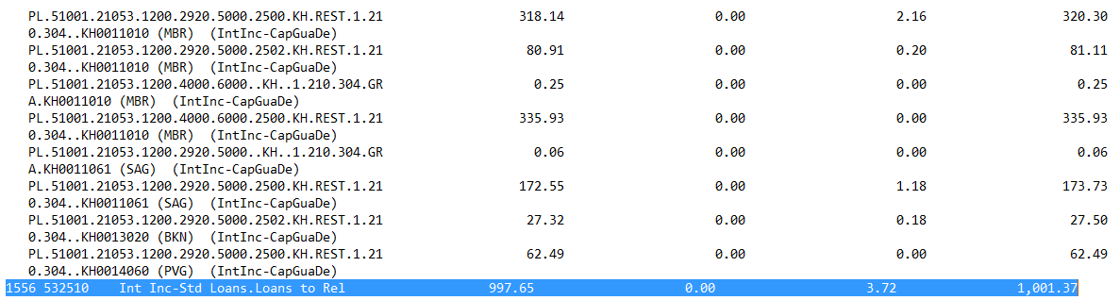

CRB-MBR

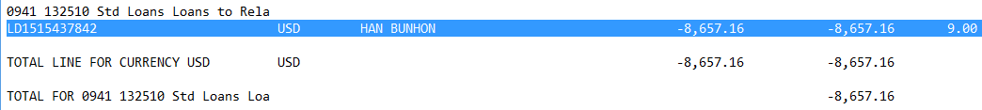



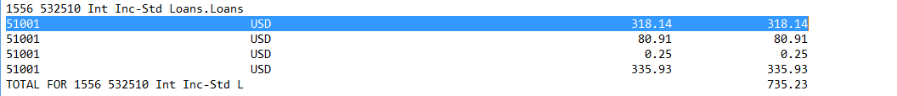

CRB-SAG

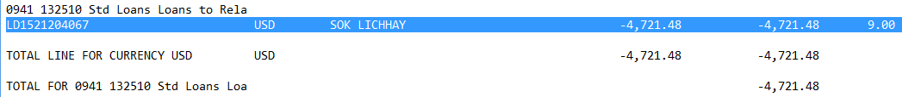

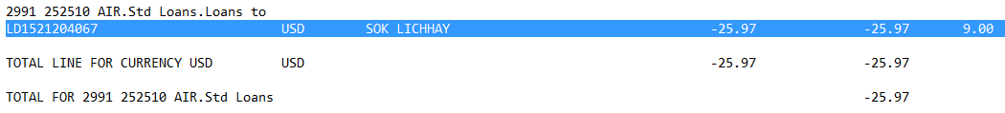



**Remap to Line:**

133120-Standard Loans – Bank Employee – Resident

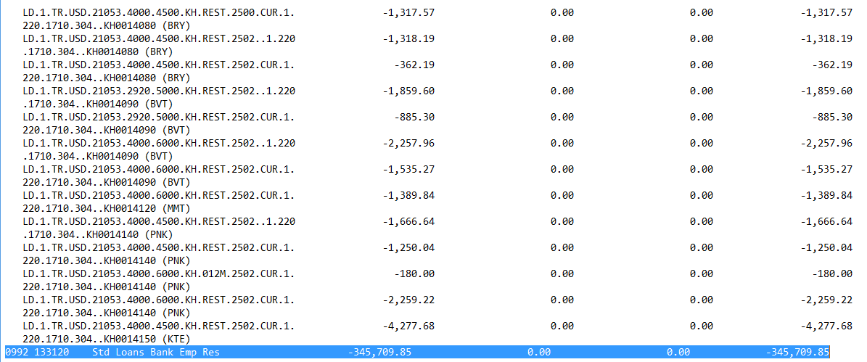

253120-AIR – Standard Loans – Bank Employee – Resident

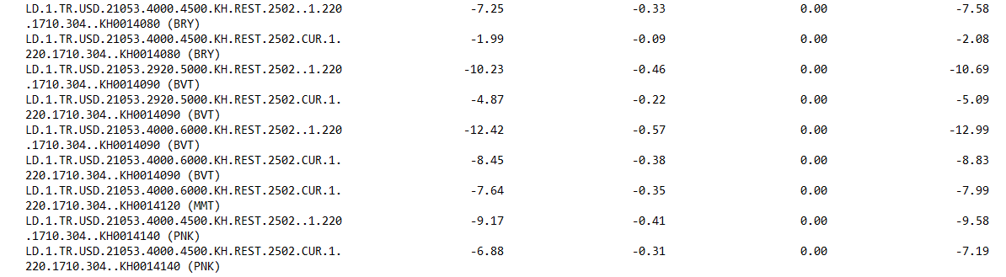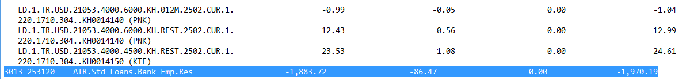

533120-Interest Income – Standard Loans – Bank Employee – Resident

